## REPORT DAY 5

## Marketplace Testing, Error Handling, and Backend Integration Refinement

## NIKE

## ****Introduction****

The purpose of this report is to document the testing, error handling, and backend integration refinements performed on the marketplace. This phase focuses on ensuring the marketplace is functional, secure, and optimized for performance, scalability, and usability before deployment.

### 

### Step 1: Functional Testing

· **Product Listing:** Ensured products are displayed correctly on the homepage.

· **Search and Filter Functionality:** Verified that search and filter options return the correct results.

· **Cart Operations:** Validated the ability to add, update, and remove items from the cart.

· **Error Handling:** Ensured proper error messages are displayed when there are issues with fetching data or API failures.

### Step 3: Performance Optimization ****Performance Test Results****:

Using **Google Lighthouse**, the following improvements were observed:

* **LIGHTHOUSE PERFORMANCE SCORE:**

The light house performance score is **89/100** on Mobile

The light house performance score is **100/100** on Desktop

The light house Accessibility score is **94/100** ,

The light house Best practices score is **96/100** ,

The light house SEO score is **100/100** ,

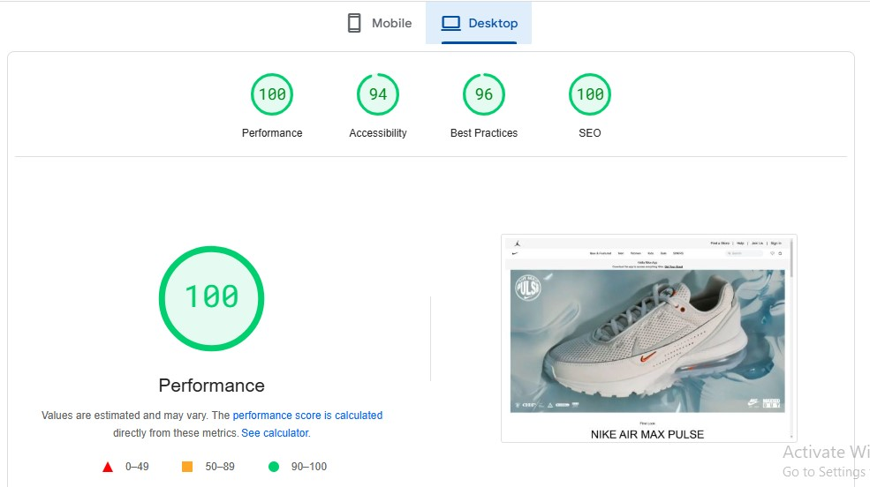

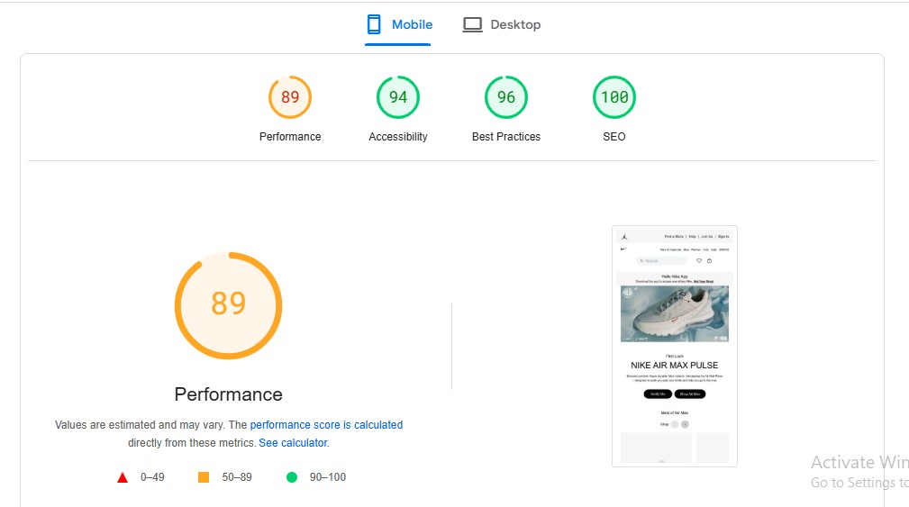

These performance optimizations ensure that the marketplace meets the desired speed and responsiveness targets, even under real-world conditions.

**TESTING ON BROWSER STACK (MOBILE):**

I conducted a testing of my website onvariouse screen sizes,here is the result,

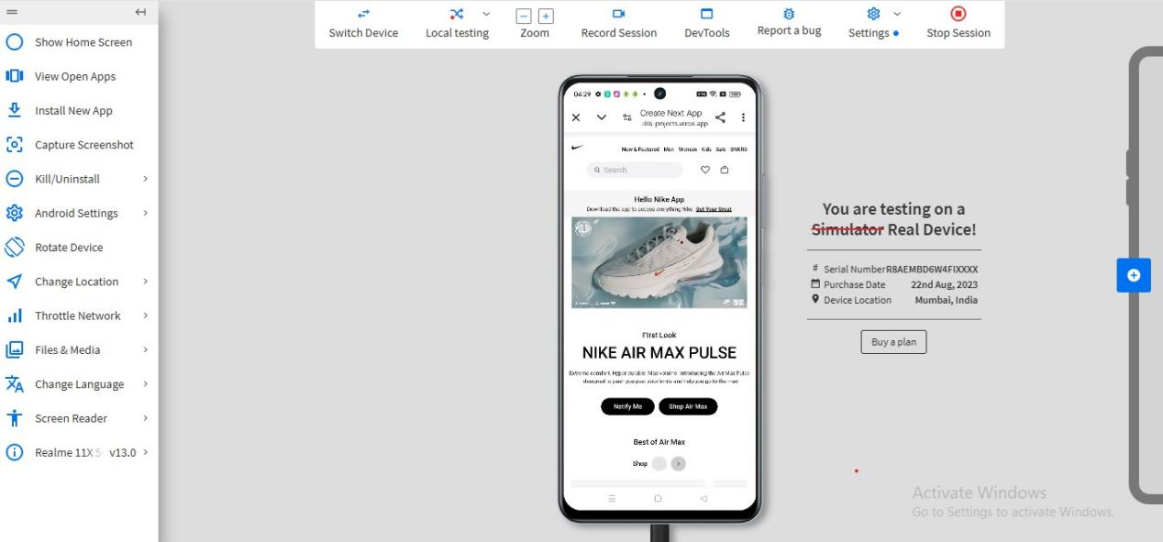

**TESTING ON BROWSER STACK (DESKTOP):**

I conducted a testing of my website onvariouse screen sizes,here is the result,

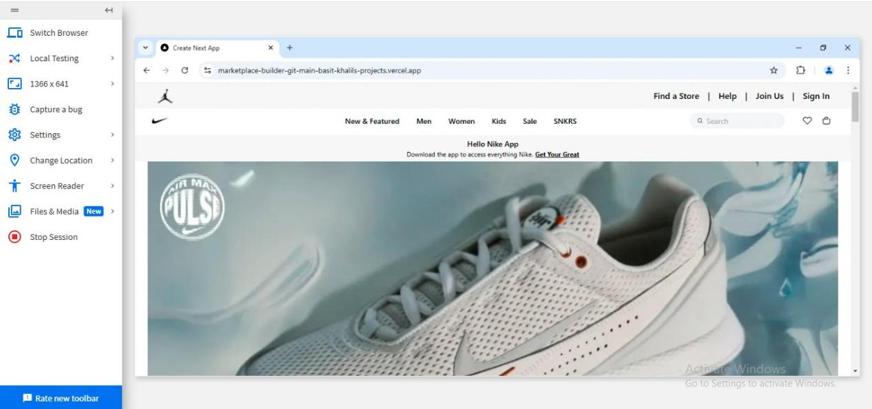

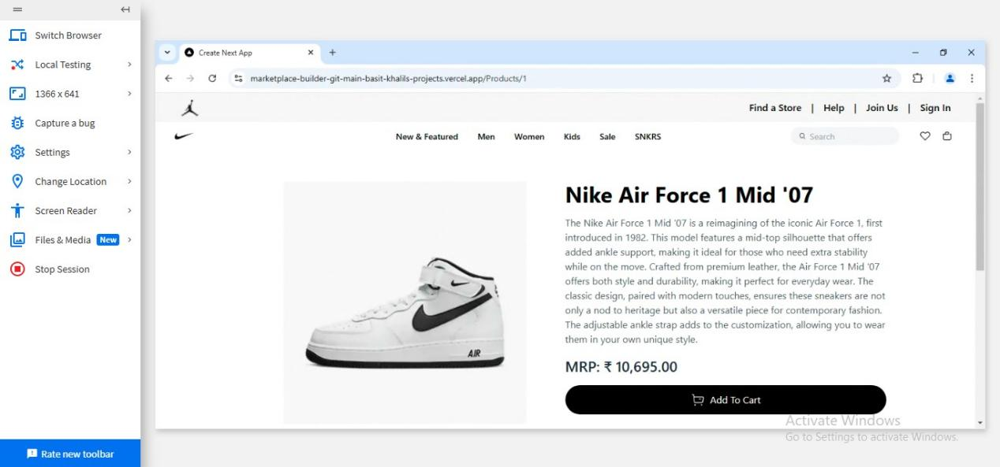

**STAGING ENVIROMENT TESTING COMPLETETION REPORT:**

****Challenges and Resolutions****

### ****Challenges Faced****:

**Cart Update Issues**: A bug was discovered when rapidly adding and removing items from the cart, which caused the cart state to desynchronize.

* + **Resolution**: Optimized the cart state update logic and implemented debounce functionality to handle rapid changes.

## ****7. Conclusion****

The marketplace has undergone comprehensive testing to ensure its functionality, security, and performance meet the standards required for deployment. Key features such as product listings, search, cart operations, and responsiveness have been thoroughly tested. Errors have been handled gracefully, with robust fallback messages and user-friendly interfaces.

### ****Key Achievements****:

* All core functionalities passed functional testing.
* Performance optimizations have successfully reduced load times.
* Security measures were implemented to safeguard the platform.
* Issues encountered during testing were resolved, and the platform is ready for deployment.